BIOGRAPHY: Akbar the Great
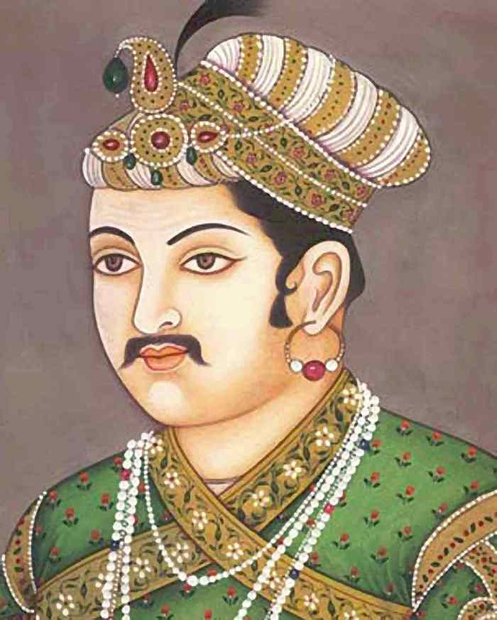
QUICK FACTS
NAME: Ab al­Fat Jall al­Dn Muammad Akbar
OCCUPATION: Political Leader, Emperor
BIRTH DATE: October 15, 1542
DEATH DATE: c. October 27, 1605
PLACE OF BIRTH: Umarkot, Sindh, India
PLACE OF DEATH: Agra, India
AKA: Akbar the Great

BEST KNOWN FOR
Akbar the Great, Muslim emperor of India, established a sprawling kingdom through military conquests, but is known for his policy of religious tolerance.

EARLY LIFE
The conditions of Akbar's birth in Umarkot, Sindh, India on October 15, 1542, gave no indication that he would be a great leader. Though Akbar was a direct descendent of Ghengis Khan, and his grandfather Babur was the first emperor of the Mughal dynasty, his father, Humayun, had been driven from the throne by Sher Shah Suri. He was impoverished and in exile when Akbar was born.

Humayun managed to regain power in 1555, but ruled only a few months before he died, leaving Akbar to succeed him at just 14 years old. The kingdom Akbar inherited was little more than a collection of frail fiefs. Under the regency of Bairam Khan, however, Akbar achieved relative stability in the region. Most notably, Khan won control of northern India from the Afghans and successfully led the army against the Hindu king Hemu at the Second Battle of Panipat. In spite of this loyal service, when Akbar came of age in March of 1560, he dismissed Bairam Khan and took full control of the government.

EXPANDING THE EMPIRE
Akbar was a cunning general, and he continued his military expansion throughout his reign. By the time he died, his empire extended to Afghanistan in the north, Sindh in the west, Bengal in the east, and the Godavari River in the south. Akbar’s success in creating his empire was as much a result of his ability to earn the loyalty of his conquered people as it was of his ability to conquer them. He allied himself with the defeated Rajput rulers, and rather than demanding a high “tribute tax” and leaving them to rule their territories unsupervised, he created a system of central government, integrating them into his administration. Akbar was known for rewarding talent, loyalty, and intellect, regardless of ethnic background or religious practice. In addition to compiling an able administration, this practice brought stability to his dynasty by establishing a base of loyalty to Akbar that was greater than that of any one religion.

Beyond military conciliation, he appealed to the Rajput people by ruling in a spirit of cooperation and tolerance. He did not force India’s majority Hindu population to convert to Islam; he accommodated them instead, abolishing the poll tax on non-Muslims, translating Hindu literature and participating in Hindu festivals.

Akbar also formed powerful matrimonial alliances. When he married Hindu princesses—including Jodha Bai, the eldest daughter of the house of Jaipur, as well princesses of Bikaner and Jaisalmer—their fathers and brothers became members of his court and were elevated to the same status as his Muslim fathers- and brothers-in-law. While marrying off the daughters of conquered Hindu leaders to Muslim royalty was not a new practice, it had always been viewed as a humiliation. By elevating the status of the princesses’ families, Akbar removed this stigma among all but the most orthodox Hindu sects.

ADMINISTRATION
In 1574 Akbar revised his tax system, separating revenue collection from military administration. Each subah, or governor, was responsible for maintaining order in his region, while a separate tax collector collected property taxes and sent them to the capital. This created checks and balances in each region, since the individuals with the money had no troops, and the troops had no money, and all were dependent on the central government. The central government then doled out fixed salaries to both military and civilian personnel according to rank.

RELIGION
Akbar was religiously curious. He regularly participated in the festivals of other faiths, and in 1575 in Fatehpur Sikri—a walled city that Akbar had designed in the Persian style— he built a temple (ibadat-khana) where he frequently hosted scholars from other religions, including Hindus, Zoroastrians, Christians, yogis, and Muslims of other sects. He allowed the Jesuits to construct a church at Agra, and discouraged the slaughter of cattle out of respect for Hindu custom. Not everyone appreciated these forays into multiculturalism, however, and many called him a heretic.

In 1579, a mazhar, or declaration, was issued that granted Akbar the authority to interpret religious law, superseding the authority of the mullahs. This became known as the “Infallibility Decree,” and it furthered Akbar’s ability to create an interreligious and multicultural state. In 1582 he established a new cult, the Din-i-Ilahi (“divine faith”), which combined elements of many religions, including Islam, Hinduism and Zoroastrianism. The faith centered around Akbar as a prophet or spiritual leader, but it did not procure many converts and died with Akbar.

PATRONAGE OF THE ARTS
Unlike his father, Humayun, and grandfather Babur, Akbar was not a poet or diarist, and many have speculated that he was illiterate. Nonetheless, he appreciated the arts, culture and intellectual discourse, and cultivated them throughout the empire. Akbar is known for ushering in the Mughal style of architecture, which combined elements of Islamic, Persian and Hindu design, and sponsored some of the best and brightest minds of the era—including poets, musicians, artists, philosophers and engineers—in his courts at Delhi, Agra and Fatehpur Sikri.

Some of Akbar's more well-known courtiers are his navaratna, or "nine gems." They served to both advise and entertain Akbar, and included Abul Fazl, Akbar's biographer, who chronicled his reign in the three-volume book "Akbarnama"; Abul Faizi, a poet and scholar as well as Abul Fazl's brother; Miyan Tansen, a singer and musician; Raja Birbal, the court jester; Raja Todar Mal, Akbar's minister of finance; Raja Man Singh, a celebrated lieutenant; Abdul Rahim Khan-I-Khana, a poet; and Fagir Aziao-Din and Mullah Do Piaza, who were both advisors.

DEATH AND SUCCESSION
Akbar died in 1605. Some sources say Akbar became fatally ill with dysentery, while others cite a possible poisoning, likely traced to Akbar's son Jahangir. Many favored Jahangir’s eldest son, Khusrau, to succeed Akbar as emperor, but Jahangir forcefully ascended days after Akbar's death.

Akbar the Great. (2012). The Biography Channel website. Retrieved 05:14, Nov 30, 2012, from http://www.biography.com/people/akbar­the­great­9178163.

Name: _______________________________
Hour: ___________

Questions
- Of which historical leader was Akbar believed to be a direct relative?

- In your opinion, was Akbar a good military leader? Give reasons why or why not.

- Before Akbar’s rule, who was taxed in India?

- The text says “Akbar was religiously curious.” Explain in your own words what that means.

- Give me one additional fact about Akbar that you found interesting and explain if a leader today could have the same trait/quality.

Name: _______________________________
Hour: ___________

Questions
- Of which historical leader was Akbar believed to be a direct relative?

- In your opinion, was Akbar a good military leader? Give reasons why or why not.

- Before Akbar’s rule, who was taxed in India?

- The text says “Akbar was religiously curious.” Explain in your own words what that means.

- Give me one additional fact about Akbar that you found interesting and explain if a leader today could have the same trait/quality.

